Criminal Details Creation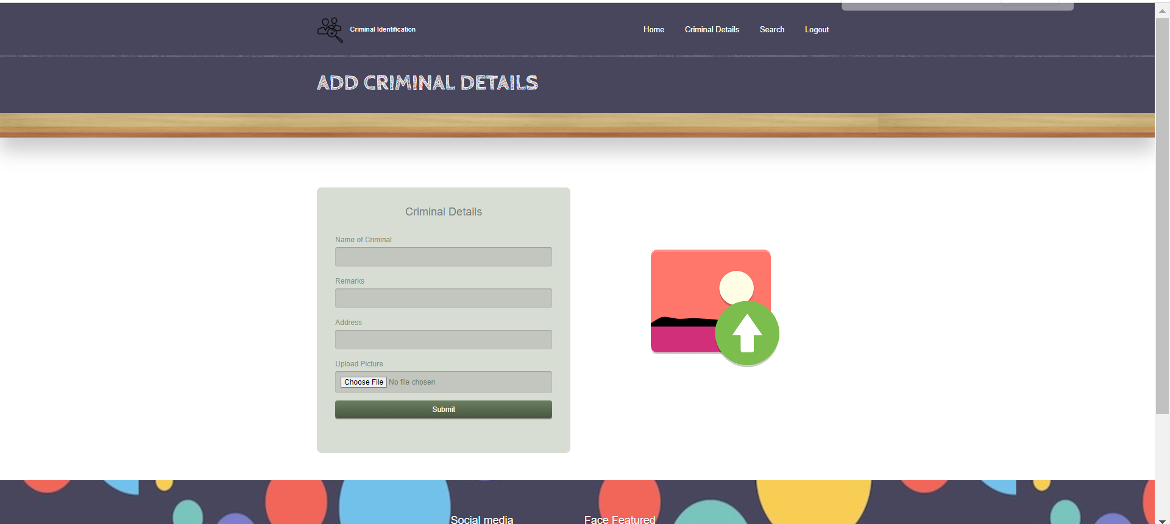 Page with backend redirected Html Page

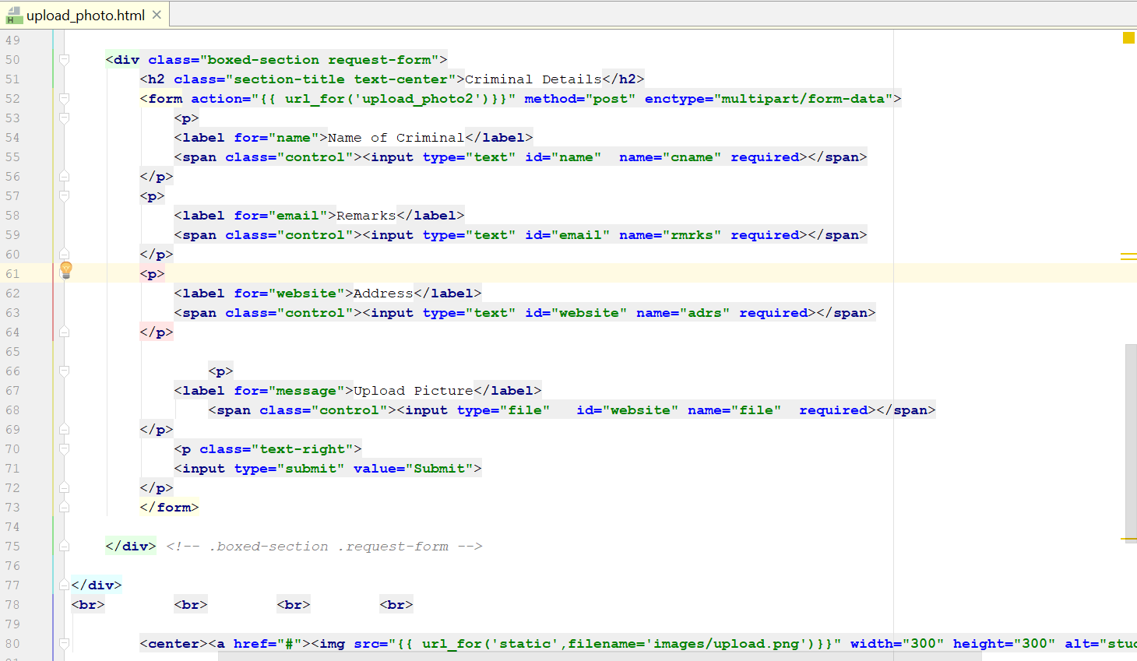

This is how we have designed the html page on backend for the criminal details creation being a authority person.